ST ALBANS & DISTRICT BOWLING ASSOCIATION
PRESIDENT : Terry Atkinson – North Mymms BC
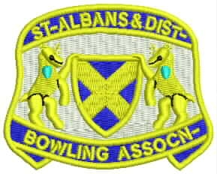

SADBA v GLEBELANDS IBC
Venue

Glebelands IBC, Summers Lane, North Finchley London N12 OPD
Tel: 0208 446 2090

Date: SATURDAY 11th December 2021 @ 14.30pm
Cost: £5.00 (Tea & Biscuits)

Report To Match Officer, Brian Burfoot by 14.00pm latest

TEAM SELECTION

Eric Marriner (Potters Bar) Chris Sage (Hatfield)
Martin Barson (North Mymms) Reg Collins ( Welwyn Garden City)
Terry Atkinson ( North Mymms) Alan Harman (North Mymms)
John Bartlett (St Albans ) Brian Smith (Hemel Hempstead)

Terry Izzard (Harpenden) Alan Rickerty (Hatfield)
Ian Hulley (North Mymms) Brian Burfoot (Potters Bar)
Peter Crouch (Hatfield) Ron Golden (Potters Bar)
David Brooks (Harpenden) Peter Stokes (North Mymms)

RESERVES: A Turner, J Turkentine

Dress Code: GREYS with SADBA shirt

Match Contacts

Brian Burfoot 01707 596438, Terry Atkinson : 01707 645320

President Terry Atkinson Supporting:
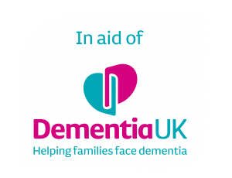

Pr

